|  |  |  |
| --- | --- | --- |
| **Lyng Primary School P.E Knowledge Organiser** | | |
| **Topic: Tennis** | Year 4 | Summer 1 |

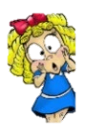



|  |  |
| --- | --- |
| **Key words** | |
| **Spelling** | **Definition** |
| Serve | A type of shot, that starts or restarts the game following a point, ball thrown above your head and hit using an overarm technique. |
| Rally | When a ball is hit back n forth between yourself and an opponent. |
| Forehand | Type of tennis stroke, racket in strongest hand sideways on. |
| Volley | A volley shot hitting the ball without bouncing. |
| Stroke | Different types of strokes, where you are hitting the ball back at an opponent. |
| Backhand | Type of shot, when holding the racket if the back of your hand is facing your opponent or where you are striking the ball, you are holding it correctly. |
| Doubles | 2 players vs 2 players |

**Enquiry Questions**

* Can we repeatedly aim towards our target?
* Do we know how to hold the racket correctly for each shot type?
* Can you keep control of the ball when striking using the forehand technique?
* What is a volley shot?
* How should you hold your racket when completing a backhand shot?
* Can we show accuracy when completing a rally or in match practice?

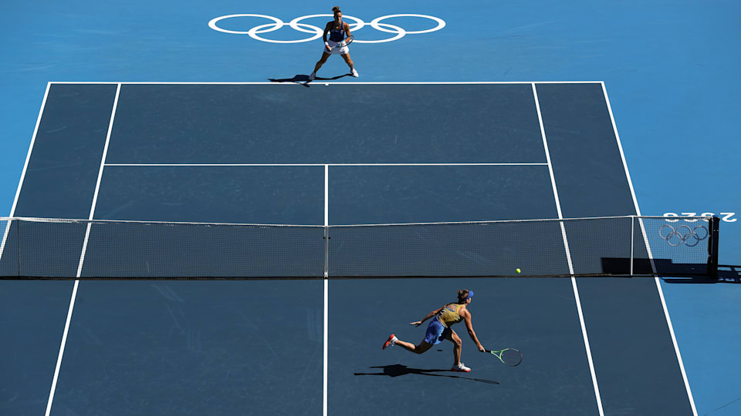

***“Practice like you play & play like your practice”***

**– Mav Levy**

|  |  |  |
| --- | --- | --- |
| **Lyng Primary School P.E Knowledge Organiser** | | |
| **Topic: Tennis** | Year 4 | Summer 1 |

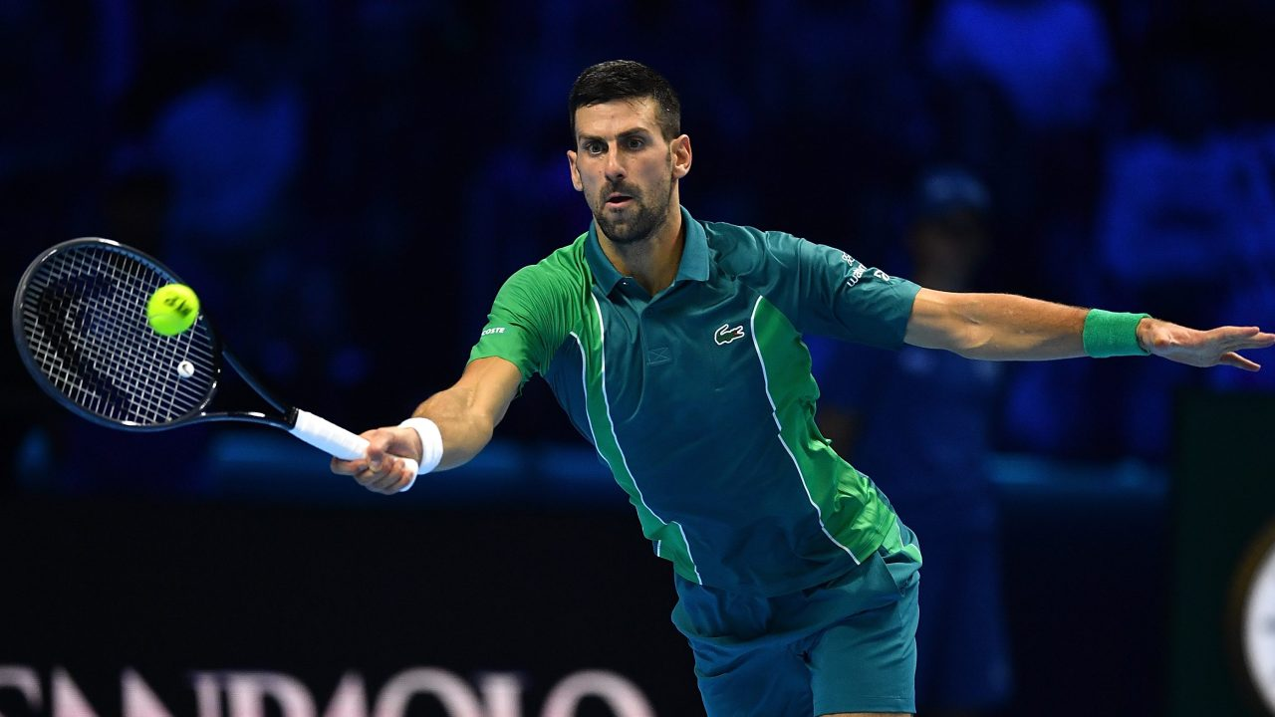

Learning Outcomes

* To develop aim by hitting targets of various strokes.
* To be able understand the different ways to hold & grip the racket correctly for each shot type.
* To be able to maintain control when using a forehand shot.
* To develop a volley shot with accuracy from various positions on the court.
* To be able to perform a backhand shot.
* To perform a rally showing good control and shot accuracy when playing a rally or match practice.